 **RNS INSTITUTE OF TECHNOLOGY**

Affiliated to VTU, Recognized by GOK, Approved by AICTE, New Delhi

(NAAC ‘A+ Grade’ Accredited, NBA Accredited (UG - CSE, ECE, ISE, EIE and EEE)

Channasandra, Dr. Vishnuvardhan Road, Bengaluru - 560 098

Ph: (080) 28611880, 28611881 URL: [www.rnsit.ac.in](http://www.rnsit.ac.in)

Department of Computer Science and Engineering

Course Name: Database Management Systems Lab with Mini-Project

Course Code: 21CSL55

Semester and Section: 5th C

**Mini Project Synopsis**

|  |  |
| --- | --- |
| Title of the Project | PAWSITIVE CONNECTIONS |
| Students Name with USN | YASHASWINI ANAND  1RN21CS184 |

**Introduction**

In the digital age, where technology intertwines with compassion, Pawsitive Connections emerges as a beacon of hope and harmony in the world of pet adoption. Pawsitive Connections is not merely a website; it's a digital sanctuary where the bond between humans and animals flourishes, and countless furry companions find their forever homes. With its intuitive interface and robust backend infrastructure, Pawsitive Connections revolutionizes the pet adoption process, making it more accessible, transparent, and fulfilling for both shelters and potential adopters.

Pet adoption is a noble endeavor that not only brings joy to families but also saves the lives of countless animals in need. In the digital age, managing pet adoption processes efficiently and effectively is paramount to ensuring that these animals find loving homes as quickly as possible. To address this need, we have developed a comprehensive pet adoption management system named "Pet Adoption." This system streamlines the adoption process, connecting shelters, adopters, and administrators seamlessly to facilitate successful adoptions

**Objectives:**

**Efficient Shelter Management: St**reamline the management of shelters by storing and organizing information such as contact details, location, and staff associated with each shelter.

**Comprehensive Pet Information:** Maintain a detailed database of pets available for adoption, including their species, breed, age, color, gender, and vaccination history.

**Adopter Engagement and Tracking:** Facilitate the adoption process by capturing information about potential adopters, their contact details, and address. Track the adoption applications submitted by adopters.

**Adoption Event Coordination:** Organize and manage adoption events, including their location, date, and participating shelters. Keep track of pets participating in each event.

**User-Friendly Interface:** Design an intuitive and user-friendly interface for interacting with the database, making it easy for staff to input and retrieve information.

**Scope:**

* **Shelter Management:** Storing information about different shelters, including their ID, contact details (phone, email), name, and location.

Allows for the addition, deletion, and modification of shelter information.

* **Pet Management:** Keeping track of pets available for adoption with details such as pet ID, name, species, breed, age, color, gender, and adoption status.
* **Adopter Information**: Storing information about individuals interested in adopting pets, including adopter ID, name, contact details (email, phone), and address.
* **Adoption Applications**: Managing adoption applications with details such as application number, application date, status, pet ID, and adopter ID.Establishing relationships between adoption applications, pets, and adopters through foreign keys.
* **Adoption Events**: Keeping track of adoption events with information like event ID, location, name, date, and associated shelter.Allowing participation of pets in adoption events through the "Participation" table.
* **Participation in Adoption Events:**Tracking the participation of pets in adoption events through the "Participation" table.

**Hardware Requirements**

Pawsitive Connections utilizes Node.js and Express for server-side development and MySQL for the database management system, the hardware requirements should accommodate these technologies. Here are the essential hardware components to consider:

• **Server**: A dedicated server or cloud-based hosting solution capable of running Node.js applications and MySQL database server.

Adequate processing power and memory to handle Node.js runtime, Express framework, and MySQL database operations efficiently.

Sufficient storage space for storing website files, images, and other assets, as well as MySQL database files.

Consider scalability options to accommodate increasing website traffic and data volume, such as vertical scaling (upgrading server resources) or horizontal scaling (adding more servers).

• **Database Server**: Utilize a robust MySQL database server to store and manage pet profiles, user data, and other application information.

Ensure sufficient storage capacity, memory, and processing power to handle MySQL database operations effectively.

Implement proper indexing, caching, and query optimization techniques to enhance database performance and responsiveness.

• **Redundancy and High Availability**: Depending on the criticality of Pawsitive Connections, consider implementing redundant systems and high availability configurations.

Use load balancers and failover mechanisms to distribute traffic across multiple Node.js servers and minimize the risk of downtime.

Implement data replication and failover strategies for both the Node.js server and database server to ensure continuous operation in case of hardware failures or outages.

**Software Requirements**

* **Operating System:**
  + Server: Windows Server
  + Database Server: MySQL
* **Database:** MySQL as a relational database management system(RDBMS).
* **Backend Framework:** Node.js with Express
* **Frontend Framework:** React.js for building an interactive and dynamic user interface.

**Database Design**

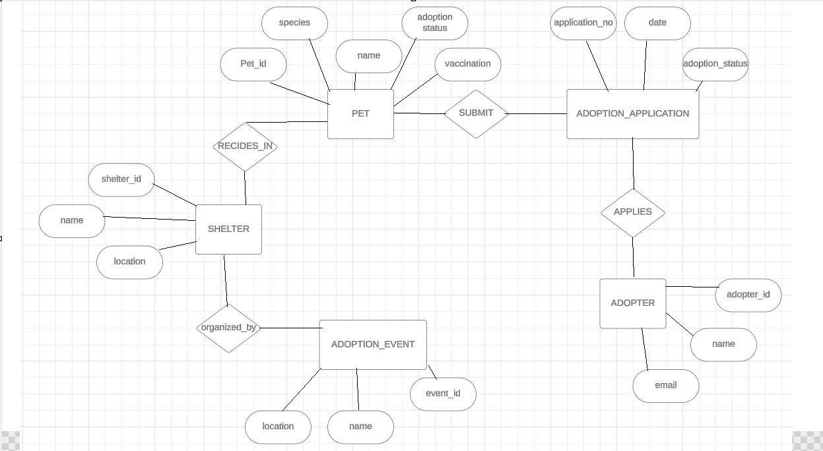**ER Diagram**

**Schema Diagram**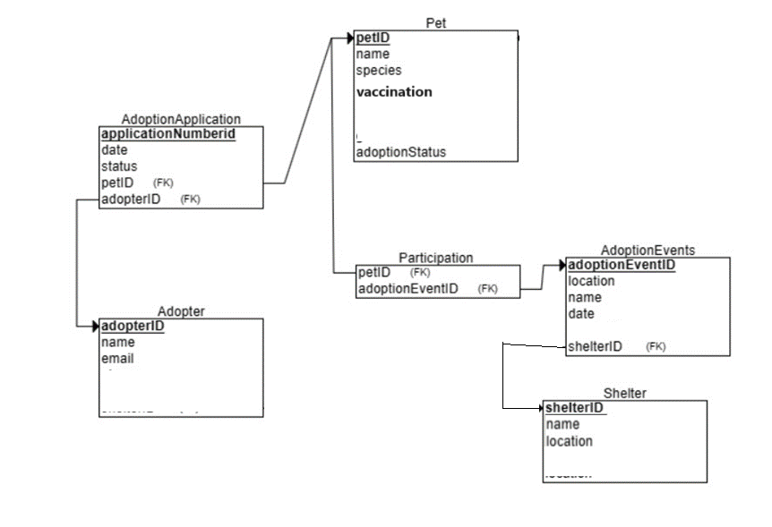

Signature of Students Signature of faculty